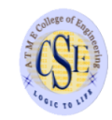
DEPARTMENT OF COMPUTER SCIENCE AND ENGINEERING

Dear Readers,

It is with great pleasure that we bring you Volume 9, Issue II of our department newsletter “CS MAIL”. The current newsletter highlights the activities of the department, achievements of faculty and students during the past six months. It also features workshop organized and attended, paper publication details and other social activity undertaken from CS Department. Your valuable comments and suggestions are appreciated.
We wish all the readers an enjoyable reading.

VISION OF THE DEPARTMENT

To develop highly talented individuals in Computer Science and Engineering to deal with real world challenges in industry, education, research and society.
MISSION OF THE DEPARTMENT
- To inculcate professional behavior, Strong ethical values, innovative research capabilities and leadership abilities in the young minds & to provide a teaching environment that emphasizes depth, originality and critical thinking.
- Motivate students to put their thoughts and ideas adoptable by industry or to pursue higher studies leading to research.

PROGRAM EDUCATIONAL OBJECTIVES PEO’S

- Empower students with a strong basis in the mathematical, scientific and engineering fundamentals to solve computational problems and to prepare them for employment, higher learning and R&D.

- Gain technical knowledge, skills and awareness of current technologies of computer science engineering and to develop an ability to design and provide novel engineering solutions for software/hardware problems through entrepreneurial skills.

- Exposure to emerging technologies and work in teams on interdisciplinary projects with effective communication skills and leadership qualities.
- Ability to function ethically and responsibly in a rapidly changing environment by applying innovative ideas in the latest technology, to become effective professionals in Computer Science to bear a life-long career in related areas.

Message From Principal

ATMECE has emerged as a prominent institute offering quality education. All round continuous changes in infrastructure and academics standard have helped us to build a brand name. It gives me immense pleasure to introduce the Volume 10, Issue I of the half yearly newsletter “CS MAIL” of Computer Science Department. I am pleased to know that the newsletter will showcase the activities and credentials of CS&E department. I hope this will become a platform for students and staff to exhibit their talents in science and technology. On behalf of management, I appreciate the newsletter committee for their efforts in bringing out this edition.

I wish the editorial all success!!!

Regards
Dr L Basavaraj
Principal, ATMECE

Message From Chief Editor

Dr Puttegowda D
HoD, CS&E

Department of Computer Science & Engineering commits to work towards developing dedicated professional with a rich blend of competent, technical, managerial and social skills to contribute nation building. I am happy to inform that our department newsletter “CS MAIL” is being released in the month of Feb 2022. The newsletter encourage departments technical activities and also motivate students to bring out their innovative ideas , hidden talents and also provide a common platform to share their knowledge, in turn gain technical knowledge.

I wish all the readers an enjoyable reading!!!

Don’t wait for opportunity create it

TOPPERS

3rd sem
USN | STUDENT NAME | SGPA
4AD20CS034 | LAKSHMI C | 8.96
4AD20CS049 | MUZAMMIL HUSAIN ABOOBAKAR SHANTAGERI | 8.67
4AD20CS032 | KAVANA K R | 9.08.63

5th sem

USN | STUDENT NAME | SGPA
4AD19CS007 | ANIRUDH NITIN BAKARE | 9.20
4AD19CS029 | KISHORE K | 9.20
4AD19CS003 | AMOGH P | 9.16

7th sem

USN | STUDENT NAME | SGPA
4AD18CS072 | SHASHANK K | 9.35
4AD18CS061 | RAKSHITHA R | 8.95
4AD18CS054 | PAVITHRA N | 8.95

EDITORIAL TEAM

Editor
Ms. Lavanya N
Assistant Professor, CS& E
Chief Editor
Dr Puttegowda D
HOD, CS&E
Chairman
Dr L Basavaraj
Prinicpal, ATMECE

A dream becomes a goal when action is taken toward its achievement
DEPARTMENT ACTIVITIES
“AWARENESS PROGRAM ON IMPORTANCE OF LATEST TECHNOLOGIES”
The department of Computer Science and Engineering, ATME College of Engineering, Mysore organized a awareness program on “ Importance of Latest technologies” on 11thAugust 2022. The Resource person this program Mr. Asgar,Academic Head, AUDAZ Ventures Private Limited , Delhi.

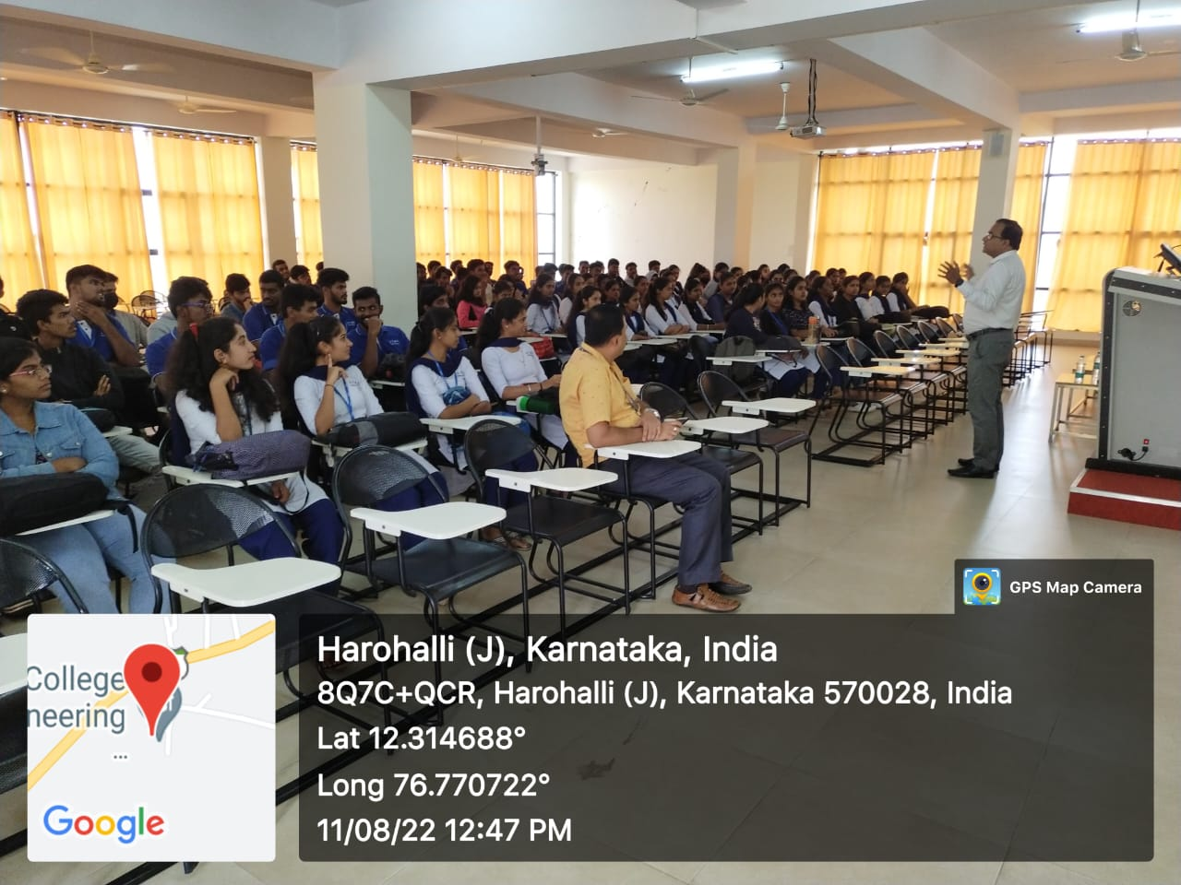
The resource person expressed that: There are many uses of technologies in our daily life. Now a day’s people use technologies to do different kinds of tasks. This is very significant for young, older and anyone who is taking benefit for modern technology, and how it will affect on us, and how it can improve our lives or other people lives. However, what is essential about modern technology which makes a real diversity in our lives. Its verification that people are using internet to receive information, especially about current or main events, and Majority of people surveyed, who is happy with their skills by using internet technology.

“INDUSTRY VISIT”
The department of Computer science and Engineering, ATMECE arranged an industrial visit as a part of the co-curricular activity to Bharat Earth Movers Limited (BEML) on December 17th 2021. About 48 students from the department participated in the visit.

The industrial visit (exhibition) was organized on behalf of 75 years of India’s Independence and to celebrate ‘AzadiKaAmritMahotsav’. The exhibition catalogues through a visual display highlighting BEML’s growth over the years and its contribution in making an ‘AtmaNirbhar Bharat’. The exhibition was on ‘BEML Journey since 1964’ where there was a showcase of 3 trucks and their new models like BH205E-Electric dump truck, BH 100-Dump truck, BG 6051-Motor grader WS28, WS70.

The visit had live demonstration of various dump trucks that were manufactured in the Mysuru plant, simulations of dump trucks, and a detailed demonstration of applications of AI and Computer Vision in the manufactured hi-tech dump trucks.
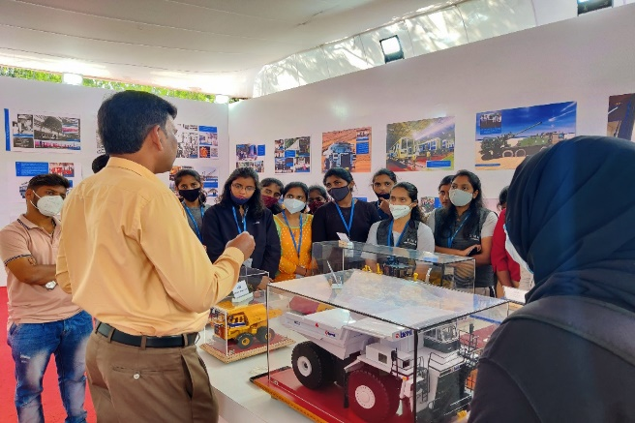
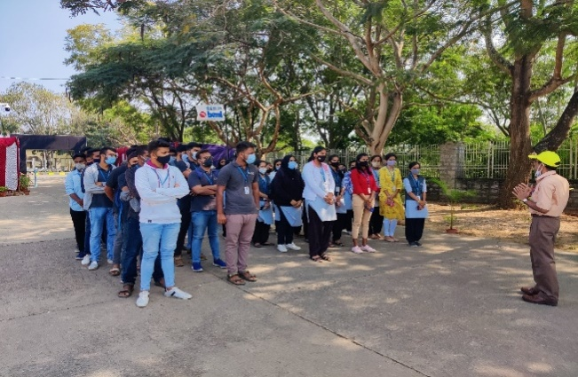

TECHNICAL ARTICLES

“Top 5 Trending Technologies to Master in 2022”

Technology is constantly updating at such a rapid pace that it seems it is might be faster than light! A technology or a programming language that is making the rounds this week may be obsolete by the next few days! As more and more funds are invested in research and development, computer scientists and professionals are constantly tweaking and improving existing technologies to get the most out of them. I have listed the top 5 trending technologies, which are expected to acquire a huge market in 2022.

Computer Vision / Natural Language Processing
- Big Data
- Datafication
- Deep Learning
- Digital Trust

1) COMPUTER VISION / NATURAL LANGUAGE PROCESSING
While natural language processing isn’t a new science, the technology is rapidly advancing thanks to an increased interest in human-to-machine communications, plus an availability of big data, powerful computing and enhanced algorithms. As a human, you may speak and write in English, Spanish or Chinese. But a computer’s native language – known as machine code or machine language – is largely incomprehensible to most people. At your device’s lowest levels, communication occurs not with words but through millions of zeros and ones that produce logical actions.
Indeed, programmers used punch cards to communicate with the first computers 70 years ago. This manual and arduous process was understood by a relatively small number of people. Now you can say, “Alexa, I like this song,” and a device playing music in your home will lower the volume and reply, “OK. Rating saved,” in a humanlike voice. Then it adapts its algorithm to play that song – and others like it – the next time you listen to that music station.

2) BIG DATA
Big Data is a collection of data that is huge in volume, yet growing exponentially with time. It is a data with so large size and complexity that none of traditional data management tools can store it or process it efficiently. Big data is also a data but with huge size. The statistic shows that 500+terabytes of new data get ingested into the databases of social media site Facebook, every day. This data is mainly generated in terms of photo and video uploads, message exchanges, putting comments etc.
Advantages Of Big Data Processing
- Businesses can utilize outside intelligence while taking decisions
- Improved customer service
- Early identification of risk to the product/services, if any
- Better operational efficiency

3) DATAFICATION
Data is a key enabler for all of these trends. All of the digitization in our world today means we have enormous amounts of data available, and data has now become the number one business asset for every organization. We can use data to better understand our customers, research key trends, and get insight into what’s working inside our organizations.The datafication process is actively used:
- Insurance: Data used to update risk profile development and business models.
- Banking: Data used to establish trustworthiness and likelihood of a person paying back a loan.
- Human resources: Data used to identify e.g. employees risk-taking profiles.
- Hiring and recruitment: Data used to replace personality tests.
- Social science research: Datafication replaces sampling techniques and restructures the manner in which social science research is performed.

4) DEEP LEARNING
Deep learning can be considered as a subset of machine learning. It is a field that is based on learning and improving on its own by examining computer algorithms. While machine learning uses simpler concepts, deep learning works with artificial neural networks, which are designed to imitate how humans think and learn. Until recently, neural networks were limited by computing power and thus were limited in complexity. However, advancements in Big Data analytics have permitted larger, sophisticated neural networks, allowing computers to observe, learn, and react to complex situations faster than humans. Deep learning has aided image classification, language translation, speech recognition. It can be used to solve any pattern recognition problem and without human intervention.
Artificial neural networks, comprising many layers, drive deep learning. Deep Neural Networks (DNNs) are such types of networks where each layer can perform complex operations such as representation and abstraction that make sense of images, sound, and text. Considered the fastest-growing field in machine learning, deep learning represents a truly disruptive digital technology, and it is being used by increasingly more companies to create new business models.

5) DIGITAL TRUST
Digital trust is the confidence users have in the ability of people, technology and processes to create a secure digital world. Digital trust is given to companies who have shown their users they can provide safety, privacy, security, reliability, and data ethics with their online programs or devices.

Digital Trust is a very important part of the expanding global economy which is becoming more and more reliant on connectivity, data use, and new technologies. In order to be trustworthy, technology must be secure as well as responsibly used.

Trust and Safety is the set of business practices whereby an online platform reduces the risk that users will be exposed to harm, fraud, or other behaviors that are outside community guidelines.

By
Department of CS & E Faculties

THINK PEACE AND LIVE GREEN…

“MAKE EVERY DROP OF WATER COUNT”

Dear Readers,
Your advice or suggestions will be much appreciated and are most welcome!!!
Please mail your articles to csdept@atme.in

Be willing to be a beginner every single morning

